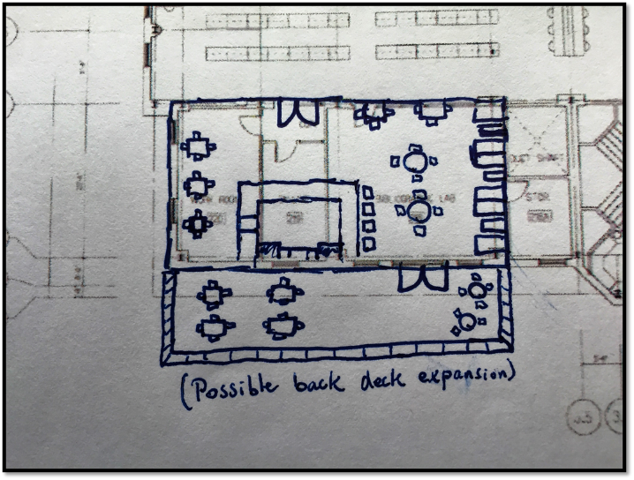

Design Option #1

The first design option for the library’s new café was inspired by the library’s need, and even the campus’s need to have something unique and interesting for its students. A large café within a library with enough room for as much expansion as one would like is just that unique thing that the campus needs. Taking away some of the office space, and reutilizing the computer lab area in the library would provide a prime location for a new vibrant café on campus. In addition to the space in the area described above, additional seating could be provided directly in front of this area (the west side by the windows of the main floor), or even behind the building where the addition of a deck would really bring something new and unique on campus. Currently, there are no outdoor seating options for the school’s main food service, the marketplace. This deck would allow for students to have a serene and comfortable location to enjoy a nice coffee or sandwich.

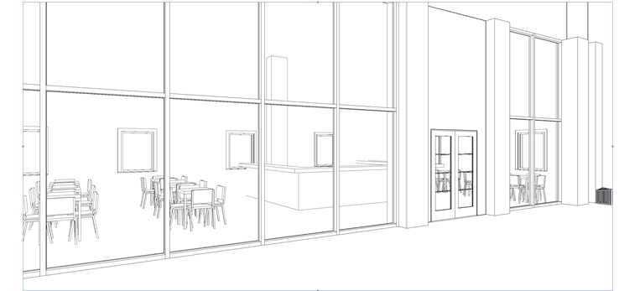

Even though a café inside a library may seem like an odd idea at first due to all of the noise that it may produce, rest assured good acoustics and noise control was factored in to the final design. As shown above, a glass wall was implemented to separate the café from the rest of the library to try and reduce any loud noises. Additionally, sound clouds were added over top of each of the tables in the café and overtop of the café bar itself. Lastly, acoustic paneling was spaced out evenly on the walls of the café. With all of these precautionary measures it is believed that the café will be a comfortable and conversational space on the outside, while keeping the rest of the library quiet on the outside. To conclude, this café design option presents endless possibilities and a fresh change to Elizabethtown’s campus.

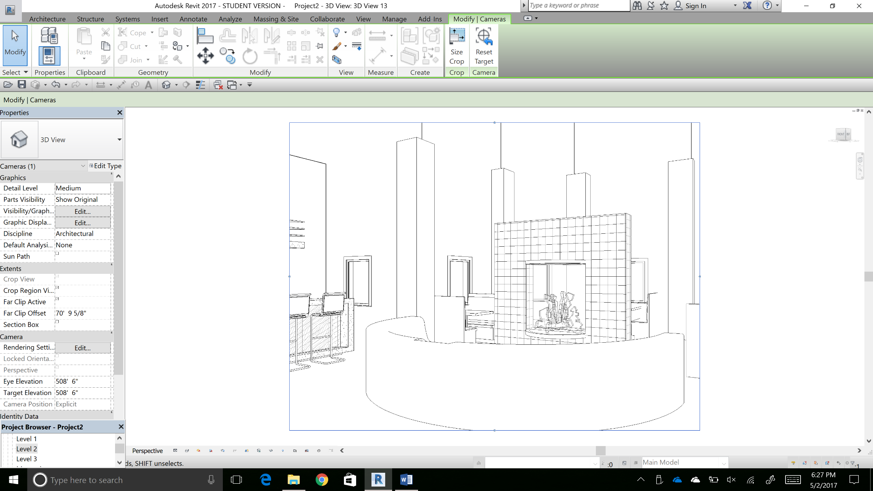

Design Option #2

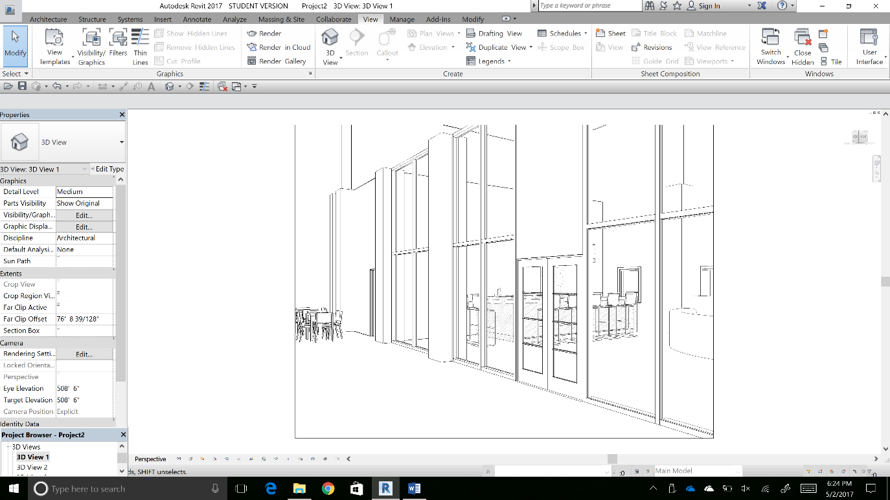

This is an image of the new exterior of our new café. The main purpose of the new glass walls is to block some of the sound from reaching the rest of the library. The glass walls create a modern aesthetic while still staying true to the style of the rest of the library. We decided to go with glass double doors because we felt it would be the most effective choice, while still being the most efficient to traffic going in and out of the café. With the addition of the glass walls and door, this design will have the ability to become an attraction for current students as well as prospective students looking at Elizabethtown College.

The primary inspiration for this design was to create a space where everyone would feel comfortable doing work and socializing quietly. With the addition of glass wall dividers, this space will feel more secluded and sound will be prevented from reaching the rest of the library. The combination of the circular couch and the fireplace will create a warm atmosphere that will work very well for the library. In the back of the image is a bar area where orders can be placed and the food will be prepared. Since this area is on the north facing side of the library some natural light will be filtered in. In addition to this, plans were made to factor in the new lighting system being installed into the library.