Field Observation: Real and Portrayed Body Types
Due: 10/14/2015 @ 9:00am

Background and Learning Objective
Social learning theory posits that our beliefs about what is normal and desirable are shaped by what we observe in the world around us. How we think and feel about ourselves is based, in part, on how we see other people behave, how they appear, and the way they are treated.
In this assignment you will assess the prevalence of different body types in two contexts: (1) a television show with a cast of human characters (real or cartoon) that a child might watch, and (2) a public place where children are welcome and lots of people are around to observe (e.g., Giant Foods, K-Mart, a family restaurant at meal times). The goal is for you to compare what children are likely to observe and learn about body types from their day-to-day experience with television vs. the real world.
Due date and points
This assignment is worth 2 points and must be completed by 9:00am on 10/14/15.
Instructions
Read over all three parts of the assignment before you begin. Spend about one hour observing the people in each type of context. Then, do the following for each context:
Part 1. Assign each person you see a number (1-9) that corresponds to the body type silhouette for women or men below that best matches their actual physique.
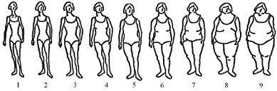
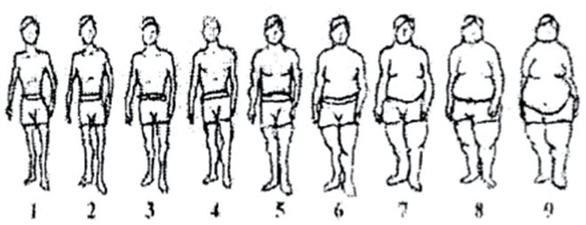
Part 1 (continued)
For both contexts, tally up the number of people with each body type (e.g., For the TV show, how many people had body type 1? Body type 2? Etc.). Then, go to Canvas and enter your results using the online survey.

Go to: Canvas PSY 226 Module: General Course Materials Assignment 2: Real and Perceived Body Types

Part 2. Looking at your results, answer the following questions on a separate sheet of paper and bring your responses to class:
- What body types were most common?
- What body types were least common?
- Did the prevalence of various body types differ between the contexts? How?
- What else did you find interesting or noteworthy? (e.g., gender, age, income differences, etc.)

Part 3. As you observe, make a note of any messages about body types that you notice. These may be obvious (e.g., a person says they are unhappy with their body) or more subtle (e.g., people with different body types are treated differently). Also think about whether the messages in these two contexts are similar or contradictory.
As you look over your notes, think about how the messages might shape a child’s belief system and be prepared to discuss what you observed during class.

