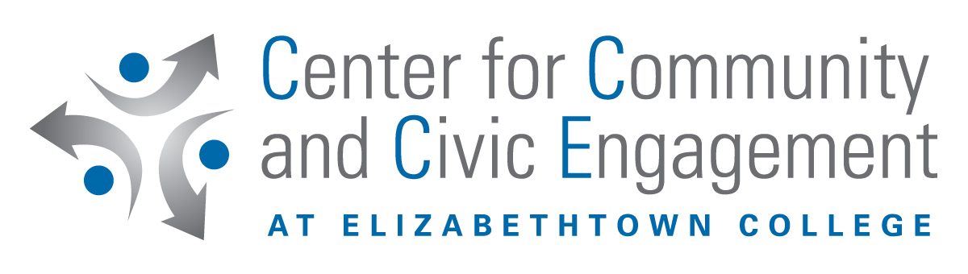
Community-Based Learning Verification

Fall __ Spring __ Year ____

Name Phone

Service placement/Agency name

Phone Placement Contact Person

As a student enrolled in , your signature below states that you agree to the following:

1. I completed hours of community service in the above named placement ending on __________. In doing so I adhered to the agreed upon dates and times of service in the Community-Based Learning Agreement that I completed and signed for this course.

2. I complied with the agency standards and regulations set forth by the contact person as well as the rules of decorum specified by the instructor for this course. I performed my service in a professional manner with respect for others and an open, caring attitude.

By signing below, the service placement contact person agrees that the student has completed the fieldwork as described above.

By signing below, the professor acknowledges receipt of this verification form.

Student Signature Date

Placement Contact Person Signature Date

Faculty Signature Date

PLEASE RETURN THIS VERIFICATION to your professor on or before the final class.

